Instructions for Completion of Laboratory Signage
(Fill in form is located on the second page of this document)
- Biological hazard signage is required for laboratories working with agents potentially infectious to humans (such as: pathogenic bacteria, viral vectors, human cell lines). The signage must be complete, printed in color, and posted to assure it is visible to anyone entering the laboratory.
- If you have more than one entrance into the BSL2 lab, the signage must be posted at each entry door.
- If work is done with an agent that possesses an increased risk to pregnant or immunocompromised individuals (such as: Listeria monocytogenes) additional statements may be required for your signage. Contact UMKC Biosafety Staff for assistance.

FIELD | INSTRUCTIONS
Biosafety Level | Identify the biosafety level from the drop down list.
Building | Indicate building. Try to avoid abbreviations when possible.
Room Number | Please list the main room number and not enclaves.
Biological hazardous Material | List all biohazardous materials used in the laboratory.
PI Contact  Name/Phone # | Principal Investigator’s full name and phone number(s) as appropriate
Training Requirements | The standard response is indicated; however; if the lab is also working with:  - Human cell lines or human blood products- Add “Bloodborne Pathogen” training.  - Add other statements as appropriate
Date | Date when updated. Check periodically to ensure all RG2 or higher materials are listed. If you update the signage be sure the UMKC IBC have approved of the use of all agents listed.

BIOLOGICAL HAZARDS
Admittance to Authorized Personnel Only
BSL 2

Building |  | Room

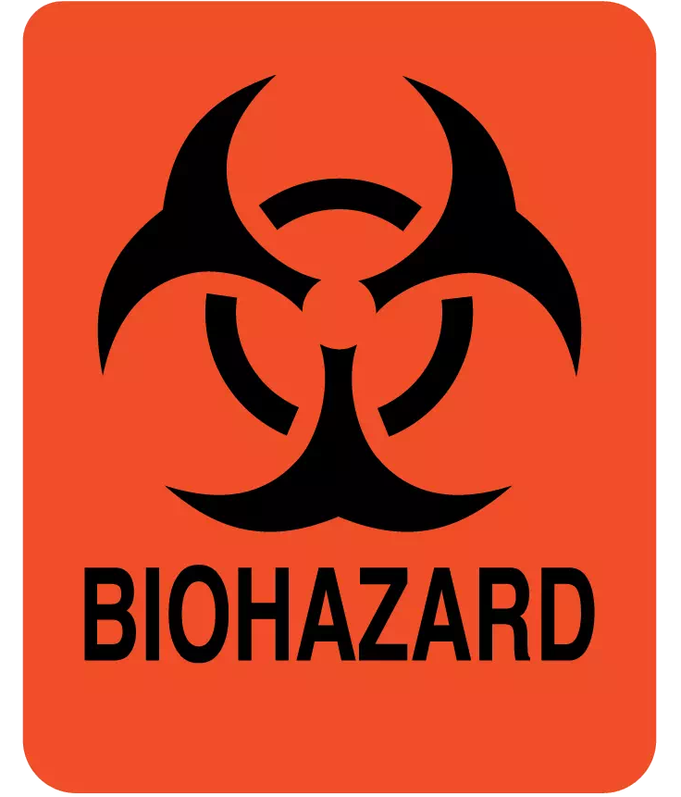

BIOLOGICAL HAZARDOUS MATERIAL(s):
Investigator(s)
Name(s) + Phone #(s):
Training Requirements: | (UMKC Biosafety Trainings, Bloodborne Pathogens, Recombinant DNA, Biosafety Level 2 Infectious Agents)
Date Posted:

